Newsletter / Website Announcement

ParentPay - our new online payment service
We are pleased to announce that all Parents will now be able to select, book and pay securely (if required) for the exact meal options for their child.

To ensure a meal is available for your child, all lunches including universal infant free school meals and free school meals are to be ordered by midnight on Thursday, at least ten days in advance of the week they are required.

What are the benefits to parents & pupils?

• Pre booking via ParentPay and tablets at the service counter help us ensure your child gets the meal of your choice every day, even if they are the last in the queue

• ParentPay is easy-to-use and will offer you the freedom to make bookings and if required online payments using the highest internet security available whenever and wherever you choose

• Payments can be made by credit/debit card or also through PayPoint

• Full payment histories, balance alerts and statements are available to you securely online at anytime

This will be starting on Monday 5th December

How to get started with ParentPay?

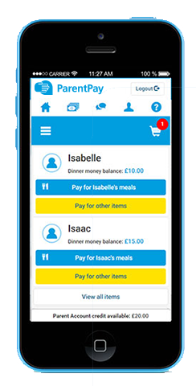
Your school will shortly send you account activation details. Once you receive these:
- Visit www.parentpay.com

- Enter your Activation username and password in the Account Login section of the homepage
NB. These are for one-time use only, please choose your own username and password for future access during the activation process

- Provide all the necessary information and choose your new username
and password for your account - registering your email address will enable us to send you receipts and reminders

- Once activation is complete you start to book meals

