Donut Bully
It isn’t BIG to make others small.
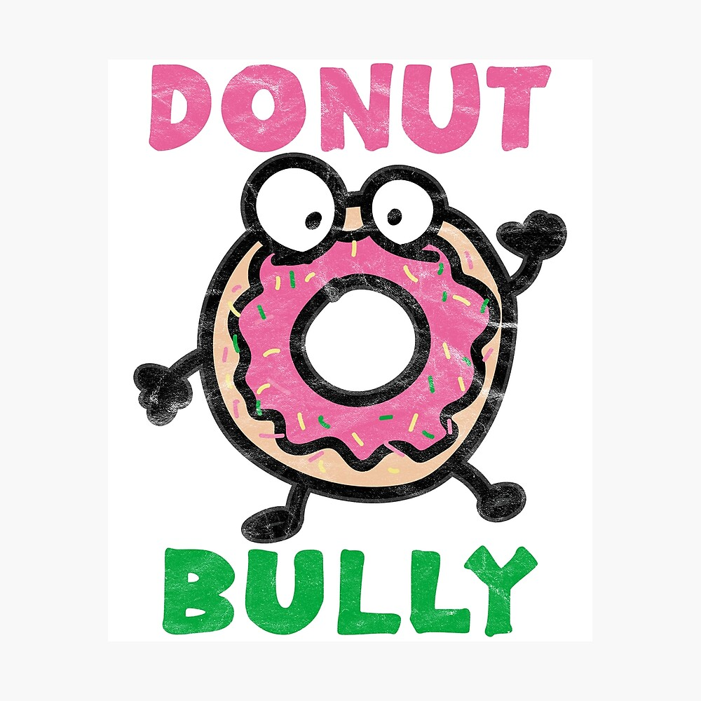
STOP BULLYING
Only you can make a change

