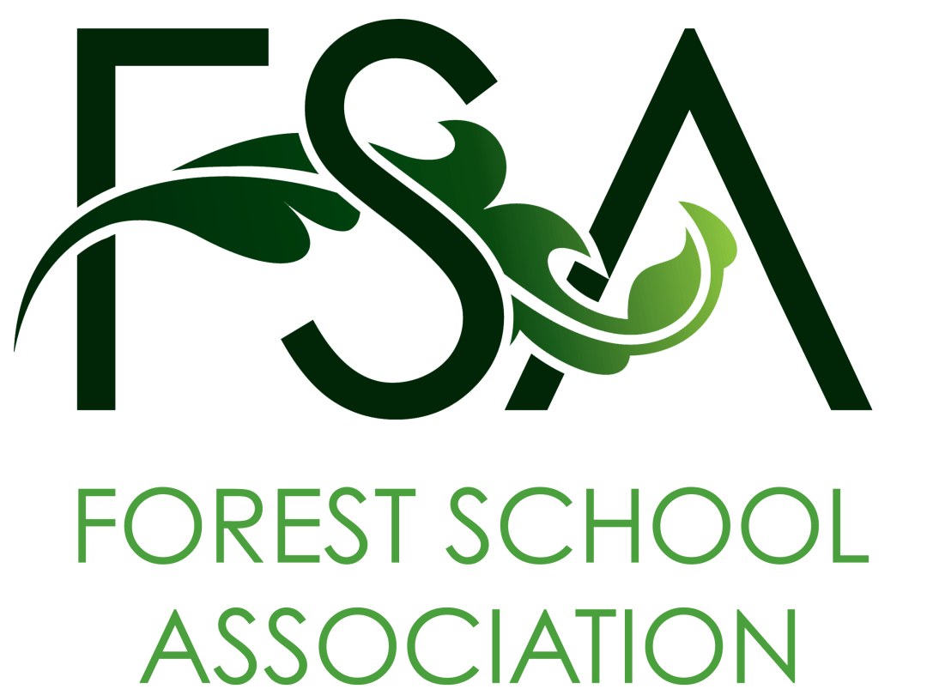

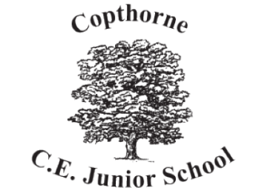
Copthorne CE Junior School
Church Road
Copthorne
West Sussex
RH10 3RD
01342 712372

September 2025
Copthorne Junior’s Forest School
Dear Copthorne resident,
Here at Copthorne Junior School, we are very pleased to announce the resumption of our fantastic Forest School programme from September 2025.
What is ‘Forest School’?
Forest School is a child-centred inspirational learning process, run by qualified instructors, that takes place in a woodland environment. It offers opportunities for holistic growth of the child through regular sessions, aiming to build resilience, independence and creativity.
It is a long-term program that supports play, exploration and supported risk taking. It develops confidence and self-esteem through learner inspired, hands-on experiences in a natural setting,
Forest School interweaves the ever-changing marvels of the forest through the seasons, enabling the opportunity to observe changes and make new discoveries, developing a strong, positive relationship with the natural world of their locality.
Where and when will Copthorne Junior’s Forest School be taking place?
Copthorne Golf Club have kindly given us permission to use the Copthorne Common woodland adjacent to their practice green for our activities.
This land is maintained by the Trustees of the Copthorne Golf Club and we have worked closely with them to ensure that all the activities to be undertaken by Forest School have been properly risk assessed, are organised and run by trained Forest Leaders and will have minimal ecological impact on the site.
We hope to run sessions in the woodland for one whole day per week from the beginning of the autumn term on each and every Thursday of the academic year, with a small group of children (no more than 15 at any time) supported by fully trained staff, walking to/from the school and accessing the woods via the entrance pathway in Knowle Close. Forest School will be bringing all the equipment and materials needed for activities with them for each session and will ensure the site is clear and tidy before they leave.

What activities will be taking place in the local woodland?
Forest School is not just about learning a few bushcraft skills (though this is one aspect), it is much more than that! Children attending Forest School learn an appreciation and respect for the woodland and develop a lifelong relationship between themselves and the natural world.
Activities, skills and experiences a Forest School learner will have opportunity to try:
- Flora and fauna identification – learning about the plants of the local woodland and how they change throughout the year
- Natural arts and crafts – modelling with locally dug clay, making natural paints and dyes, creating pictures and models (including weaving and collage) from woodland materials
- Wood craft – shaping natural materials using a bow saw, wood axe, camp knife, palm drill and other tools safely
- Animal identification and tracking – learning about the woodlands inhabitants and identifying them from their tracks and sounds
- Den making – using natural fallen materials to create a practical habitat, whether for a person or one of the woodland’s many inhabitants
- Fire making – learning controlled and responsible use of a flint and steel to make a small communal fire, understand fire safety, prepare and cook camp foods and drinks … and to remove all evidence of the fire at the end of the session.
- Learning traditional woodland folklore – create magic in the woods with stories of the ancient magic that surrounds the trees, animals and faeries that live there!
- A chance to chat and communicate – children helping and supporting each other as they learn and play, fostering greater resilience and self-confidence
- Games galore – whether to develop trust using blindfolds, learning to camouflage while stalking as a predator or prey or making up new games with a friend, the possibilities are endless!
- Learning about environmental impact – understanding how their own activities can impact the woodland and learning to evaluate and minimise this. To keep the woods clean and tidy, monitor the flora, fauna and wildlife throughout the year and inform the land management of any concerns or ideas to improve the local forest environment
- Communicate all they have learned with their peers at school and local community
We truly hope you will support the children of Copthorne Junior School in taking their first steps in creating a Forest School in the heart of the village, following our adventures and watching as the Forest School develops through the school’s website (https://www.copthorne.w-sussex.sch.uk/forest-school/) or by chatting to pupils and parents in the local community.
Should you have any questions or want further information, about our Forest School please contact the school on 01342 712372.
Mrs Helen Denison (Head Teacher) Mr Jeff Turner (Forest School Leader)

