RISK ASSESSMENT AND RISK MANAGEMENT FOR SCHOOL TRIPS

RISK ASSESSMENT FOR OFF-SITE ACTIVITY

ACTIVITY: FOREST SCHOOL ACTIVITY ZONE (off-site from Copthorne Junior)

DATE: EVERY THURSDAY (all day) – FROM SEPTEMBER 2025

Name: JEFF TURNER Organisation: Copthorne CE Junior School

Assessment review undertaken (date): Thursday 31st October 2019 (Jeff Turner and Mike Gould – Grounds Manager of Copthorne Golf Club)
Draft completed - Monday 11th November 2019 (Jeff Turner)
Reviewed (following storms + winter) – Friday 6th March 2020 (Jeff Turner)
Reviewed – June 2020
Reviewed by Forest School Association – June 2021
Reviewed and Updated – September 2021
Reviewed and Updated – September 2022
Reviewed and Updated – September 2023
Reviewed and updated – September 2024
Reviewed and updated – September 2025

Assessment Review Date: Ongoing dynamic assessments made throughout 2025/26

LIST HAZARDS HERE | List of groups of people who are especially at risk from the significant hazards you have identified: | How will you control this risk? (You can append or refer to relevant documentation that explains your safety arrangements, e.g. letter to parents, booklet prepared for students, letter from residential centre, extract in safety manual etc. | Post event review (use this column to comment if you have a concern or an incident occurred)
DAILY RISK ASSESSMENT | EVERYONE | Before each site visit, a daily site risk assessment will be undertaken.  This will assess:  - Wind conditions  - Extreme weather conditions  - Activities to be undertaken  - Tools to be used  - Group to be taken  - Medical needs of group  This daily risk assessment will be seen by all accompanying adults, as well as (where appropriate) discussed with group
Communication / Organisation | Everyone on the trip | WHEN PLANNING A TRIP, TEACHERS SHALL REVIEW THE GENERIC RISK ASSESSMENTS BELOW AND CARRY OUT SITE SPECIFIC RISK ASSESSMENTS IN CONJUNCTION WITH THE VENUE MANAGERS  Prior to visit to Forest School site, group leaders to be briefed and provided with key documents including:  - daily risk assessment  - generic and site-specific risk assessments (including maps and walking to/from)  - emergency procedures  - list of leaders (including mobile phone numbers)  - allocation of children to leaders / activities to leaders  - day itinerary and activities to be undertaken  - risk assessments for tools being used and their safe use and storage  - risk assessments for activities being undertaken  - specific adult roles and responsibilities  - emergency contact numbers.  Prior to departure from school, teachers to register children on BromCom and confirm groupings in school hall/classroom or on playground.  Teachers to collect medication and give to designated lead first aider.  Lead first aider (in addition to Forest Leader) will be named in DAILY RISK ASSESSMENT, though JEFF TURNER is also a fully trained Outdoor First Aider  All staff and adults to be carrying mobile phones set ‘silent OFF – ring tone maximum’  All staff and office to have a list of all contact details for travelling members of staff  All staff will know their role should an emergency take place or the Forest Leader be unable to undertake their role  Copies of all the above documentation will be left and available for reference and use in the school’s office prior to departure.
Prior to departing school | All adults and children | Group leaders will:  - register children prior to departure in class (with teacher on BromCom) and again with Forest School Leader on playground  - check that children have all personal and appropriate clothing, equipment, lunch/snacks, water bottles and other belongings required for that session  - talk to the children about safety  - remind children to follow any instructions from any adult or group leader, both on the journey to/from site, as well as within the Forest School area  Lead First Aider will ensure that:  - The Forest School First Aid bag is fully stocked, appropriate for the activities to be undertaken and taken to site  - Additional mini first aid kits are fully stocked, appropriate for activities being undertaken and provided to all accompanying first aid trained staff  - Accident recording forms/folder is taken  - All medication needed by children is accounted for  - A list of children with specific allergens or medical needs is taken (and that all staff are aware of these children)  - Fire blanket, fire gloves and fire bucket are available (with sufficient clean water)  Forest School Leader will:  - Prepare all equipment needed for activities in advance of visit  - Ensure all equipment is safe for use  - Have a clear plan and itinerary for visit  - Be aware of weather conditions and plan accordingly  - Ensure children have been briefed in advance as to equipment / clothing required for visit (weather / site condition appropriate)  - Ensure children have clear expectations of behaviour  - Ensure all accompanying adults have a clear understanding of roles, responsibilities and how to minimise risk and maximise enjoyment  - Ensure all adults know how to supervise, support and (where appropriate) lead activities  - All accompanying staff and office have copies of all relevant mobile numbers and these pre-programmed into phones  - All accompanying adults will have read:  - site risk assessment  - activity risk assessments (relevant to the day)  - tool risk assessments (relevant to the day)  - emergency procedure document (and understand their role)  - poor weather procedures  Children will ensure:  - They have appropriate clothing suitable for the visit / activities / weather  - Bring a small day bag containing water and snack (and any other specific equipment or clothing suggested in advance, such as sun hat, gloves etc…)  - They follow the rules and expectations of behaviour set out by the Forest School leader and all accompanying staff
Walking to/from Forest School Site | Anyone | Journey from school to site is approximately 10 minutes  SEE ATTACHED MAPS FOR LOCATION AND WALKING ROUTE  Children walk on pavement at all times  There will be a lead adult at front and an adult at very end to ensure no children fall behind  All adults wear yellow high visibility jackets  When crossing roads (The Glebe, Church Road and Knowle Drive), children wait until TWO adults are supervising and walk between both. Though roads are very quiet, adults and children should be vigilant at all times for vehicles
Transportation of tools and materials | Anyone | Children carry Forest School equipment and resources needed for activities of appropriate size and weight for their personal size and strength. Equipment carried should not make walking unsafe or restrict visual abilities  Heavier equipment and materials (such as log horse, large volumes of water or heavier / longer sections of wood) will be transported by two large heavy-duty trollies.  Where needed or appropriate, larger or heavier materials will be transported to site entrance in advance by car. The car will be parked adjacent to site entrance for short distance transportation, with materials picked up and moved into site upon arrival by group.  Firewood and extra clean water (2x20 litre drums) will be dropped off at the Forest School site during the morning site risk assessment.  Tools will be stored and carried in closed boxes or heavy-duty bags.  All tools transported will have (where appropriate, such as knives or axes) guards or sheaths in the closed / locked position. Any tools with sharp or pointed ends (such as hand drills) will be in closed boxes.  Tools will be (where possible or appropriate) carried on the trollies or by car to minimise risk.
Forest School Site |  | SEE ATTACHED MAPS FOR SITE LOCATION AND ACCESS  The site is off SPRING GARDENS and accessed via a public footpath running along the back of residential properties  The site is part of Copthorne Common and a Tree Protection Site, under the rules and regulations set out by Mid-Sussex District Council and monitored and maintained by the Trustees of Copthorne Golf Club.  Permission has been granted by the General Manager (Amanda Godwin) to use the site after submission of all signed and checked documents showing appropriate risk assessments, public liability insurance, a letter ensuring no liability for Copthorne Golf Club and communication for local residences and club members of activities and timings under which the Forest School programme will be undertaken.  A risk assessment was undertaken with Mike Gould, the Head Greenkeeper of Copthorne Golf Club, to discuss the activities to be undertaken, discuss historical use of the wooded area and identify potential risks from the golf club and public access  Mrs Fletcher, the Tree Protection Officer with Mid-Sussex District Council, has also been contacted to grant access and permission to use this land for Forest School activities and to act as advisor as needed.  Potential Risks in / around Forest School site:  Risks at the site will change from week-to-week and season-to-season, so all adults and children should be aware that each visit may offer different hazards.  Strangers: The area is public access, though not heavily used. Members of public are likely to walk through the zone using one of the half dozen access points. Strangers should not be approached by children. Children are not to walk around woods alone or out of sight of an adult (wearing a yellow high visibility jacket). If an adult approaches the group / children, an adult will be on hand to supervise and lead discussion as needed  Dogs: The area is public access and is commonly used by local residents to walk dogs. Dogs may or may not be on a lead. Should a dog approach that is off the lead, children should not attempt to touch the animal. Children will be advised to cross arms out of reach of the dog’s mouth and not maintain eye contact. A dynamic assessment of the risk posed by the dog will be undertaken at the time and on circumstances (e.g. on lead, owner present etc…).  Animal faeces: There is a risk of coming across both domestic animal and wild animal faeces. Children should be aware of the risk and be vigilant of where they walk and sit. There is also a risk of dog waste collected by owners in plastic bags being left in the woodland and these should not be touched. Children should also be aware that animal faeces located and correctly identified can also aid in identifying wild inhabitants within the woods and are a natural part of the woodland ecosystem  Uneven ground: The area is generally fairly flat, but there are many areas of uneven ground, including pot holes, ditches and small pools of water. Care should be taken at all times and children encouraged to identify hazards and discuss methods to minimise risk  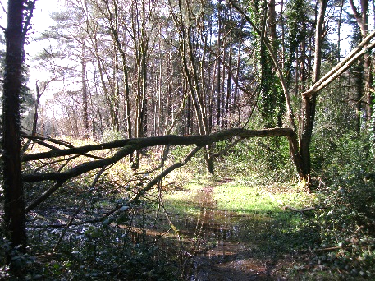  Thorns / nettles / brambles: All areas away from paths and clearings have a carpet of brambles and nettles. These are taller and denser in some areas. This is a seasonal risk. Children encouraged to stick to paths and open areas to minimise risk. If the children need to touch plants with potential stinging leaves or thorns, they should always wear gloves and have closed shoes and long trousers  Low hanging branches: There are several areas where branches have fallen or grown low, though many of these are removed by the public or through maintenance by the golf club. Where these exist, children should ensure they observe and avoid where possible  Ponds / Water-filled ditches: This is seasonal and weather dependent. Drainage of the site is quite poor and during prolonged periods of wet weather or during the colder months, the ditches and lower areas become filled with water and an area directly crossing the main clearing becomes very wet and muddy.  The central zone connecting two ditches floods during the wet winter months or after prolonged heavy rain, linking both ditches together. During this time, the water hazard is up to 2m wide and up to 1m deep. This area is still dry and passable at one end.  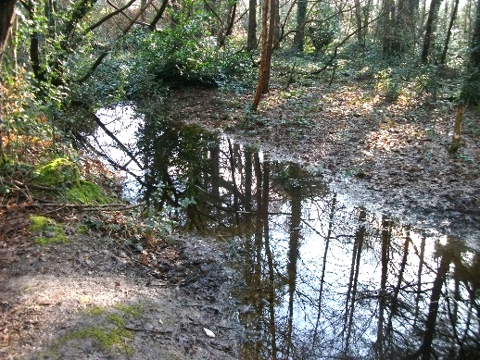  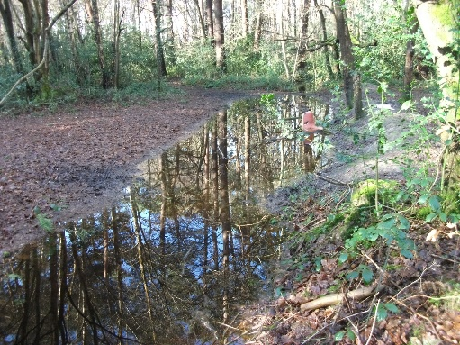  Children should be aware of their location, the risk they pose and the dangers of the surrounding wet and slippery ground that may cause increased dangers.  Water hazards are not deep (no more than 30cm) during dry / summer and autumn months – at this time, water hazard risks are minimal. From May through to September, most water hazards have entirely dried up.  Children are made aware of the dangers posed by stagnant water, with regards to bacteria and will avoid contact with this water where possible, or, where this is unavoidable, thoroughly wash hands after contact.  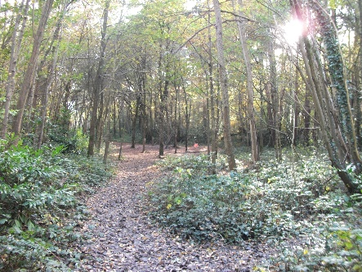  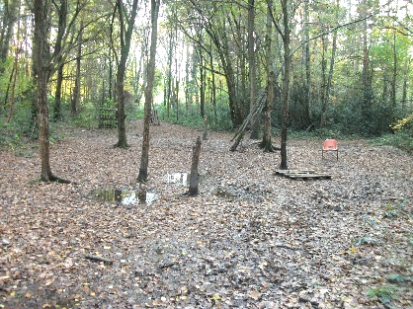  Wet, muddy, slippery ground: During the winter and during periods of extended rainfall, the ground is wet, muddy and (in a few places) boggy. This does not pose a great risk, but is slippery and the mud deep in areas that could cause children to slip and fall … or simply overflow into footwear. If mud is a hazard, appropriate footwear should be worn (such as wellington boots) or simply walked around to avoid  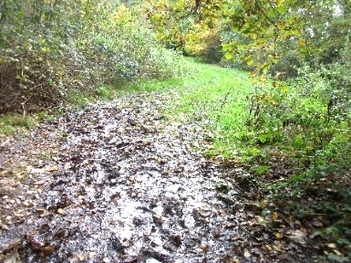  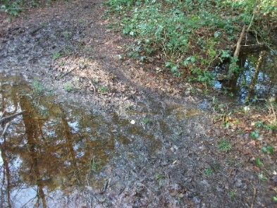  Wandering off / leaving designated zone: The area is not fenced off in any way and has full public right of way. There are multiple points of access and the woods are bordered along one side by the practice fairway of Copthorne Golf Club. The woods are thick enough in places to restrict view. Children are to always be within sight of an adult wearing a high visibility jacket. When working with a group away from the main clearing zone, children are to stay with the group and adult. Children are able to move freely around the woods, but always with a partner and always within sight of an adult. Children will be walked around the whole woodland zone during induction and discussion will be had about appropriate boundaries and safety. Clear markers, both natural and bright red painted spots on trees, will ensure children stay within agreed designated area. These boundaries are reviewed and identified at the start of each session.  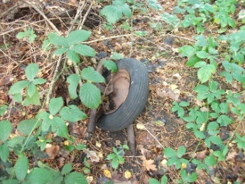  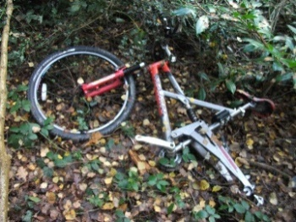  Litter, including broken glass, rusting metal and sharp objects: The area is public access and used by local residents and children of all ages. There is not a great deal of litter at the site, but this varies greatly depending on season and who has been using the area. Potential risks identified (though not necessarily observed on visit) are: broken glass, rusting or torn cans, thrown away foodstuffs, dumped scrap metal (e.g. old bikes), rubble and general litter. We have also been made aware that historically the area has been used for drug taking and needles or gas canisters have been collected – though this is very rare and not seen for more than a year. Where possible, adults will walk the site in advance of or with the children to identify litter risks. Where possible these can be removed or safely collected and disposed of. Children should be made aware of all potential litter risks and understand not to touch them and instead inform an adult  Getting lost within wooded area: The wooded area is not large and bordered on three sides by residential properties and the fourth by the practice fairway of Copthorne Golf Club. Most of the children will be familiar with the site due to local out of school use. The woods are dense in places, with restricted views. There are approximately 6 main paths through the woods and several old overgrown paths no longer in use. It is difficult to get lost or be out of earshot due to the limited area, but children should ensure they are always within sight of an adult with a high visibility jacket and never to walk off alone. If a child finds themselves away from the group, they should stop, listen, retrace steps and call for help  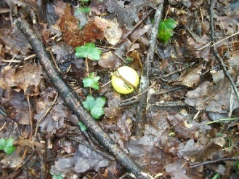  Golf balls: Head Greenkeeper explained that the woodland is adjacent to the practice fairway stretching from the clubhouse. This is used infrequently during the winter months, but regularly during the summer period. During this time, golf balls may veer into the wooded area being used. Though most will not penetrate far, they can come in up to 20m or so. Children need to respect a boundary zone away from the fairway. This will be discussed and identified during orientation, with a boundary zone identified at safe distance away from fairway to minimise risk and marked with red spray paint on the boundary trees  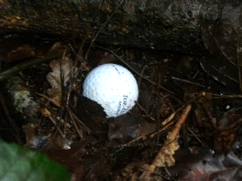  Poisonous plants, fungi and berries: There are a wide range of plants growing in the wooded area. During the late autumn risk assessment, a variety of mushrooms and other fungi were identified. During the spring, most plants have died back with the understory opening up. Bramble remains a risk all year round. Other plants will produce seasonal fruits and berries. Some plants may also be dangerous to the touch or if ingested.  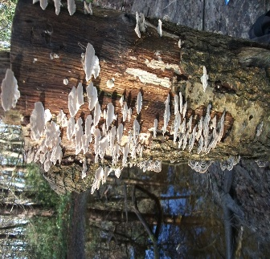  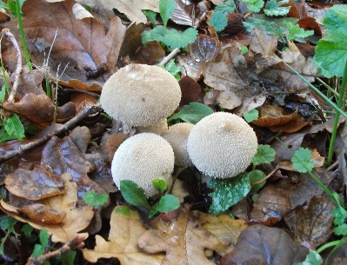  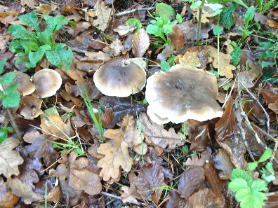  Where possible, children will identify these plants in situ and discuss the risks and how to minimise threat. Where a plant is not identified in advance, children should understand risks and minimise dangers to themselves. They should speak to an adult when unsure and never touch or eat unfamiliar fruits, berries or fungi.  A flora and fauna identification booklet will be created throughout the seasons (with photos) as a site encyclopaedia for plants (and animals). Additional reference books and mobile phone Apps will be on hand to identify any new or unfamiliar species.  Animal holes / dens (e.g. fox or rabbit): Various wild animals live within the woods, including a family of foxes and other burrowing animals. Burrows and holes are not frequently in the main public areas, but children should be aware of potential hazard
Toilets | Anyone | There are NO toilets on or near the Forest School site  Children will go to the toilet prior to leaving, but may need the toilet during an extended session – with visits being all day (approximately 6 hours)  A toilet tent will be carried to the site and set up immediately upon arrival at the Forest School zone. Adults (and later children) will be trained in set up, with a shallow hole dug and tent placed over. Toilet paper and a plastic bag will be provided inside to dispose of used materials. Hand wash and disinfectant will be provided  At the end of the session, the tent will be taken down, hole filled and covered and any used waste materials returned to school for safe disposal
Medical | Anyone | All children will have supplied to the school a comprehensive, West Sussex approved Medical Form detailing allergies and any illnesses. An additional Forest School specific permissions and medical form will be provided and completed with information related to insect bites and allergies.  Copies of this form will be available at school and to leaders. All leaders will be made aware of any children at risk of allergens or requiring medical attention (e.g. medicine) while on the visit.  Children with asthma will have their pump on them at all times, as well as group leader carrying a spare. Similarly, for children requiring an epipen.  As the site is an offsite wooded area, there will potentially be the possibility of fruits, nuts and berries (such as acorns etc…) at certain times of the year. Those with any allergen to nuts will ensure they do not touch any of these items!  There will be a designated lead first aider for each visit in addition to the Forest Leader for each visit, with a qualified first aider on hand at all times. The site is just 5-10 minutes walk from school and if needed, a child can be escorted back (if a spare adult is available) to the school or a call made to the school for additional assistance.  If a more serious incident occurs, emergency services will be contacted directly along with the school.  Adult to child ratio will always be as such that ‘spare’ adults can assist with a medical incident without affecting activities or putting others at risk. If required, activities that require direct adult supervision (such as knife work or cooking) will be stopped while the medical incident is addressed.  All accidents, incidents and ‘near-misses’ will be recorded. This information will be used by the school as well as to inform future planning.
Emergency Procedures | Anyone | Should a major incident or accident occur, the site EMERGENCY ACTION PLAN will be used (see separate documents).  Evacuation of site, contact with appropriate persons or emergency services, assembly point and site access information for emergency services are all contained in this document.
Allergies | Those who suffer from allergies | Where food technology activities are to be undertaken as part of the visit, ingredients and foods are to be obtained in advance and any potential allergy issues identified.  All proposed activities should be reviewed for allergies in conjunction with the West Sussex medical form.  Children will take their own lunches and snacks. The strict ‘no nut’ policy used at school applies to this visit.  There are a number of children who are identified as ‘gluten-free’ and these children will be provided with their own specific breads and biscuits to ensure full participation in all cooking activities. Cooking equipment used will be cleaned or specifically allocated to ensure there is no cross-contamination of gluten food ingredients.
Halal | All staff and relevant children | We have a number of children of Islamic faith who are halal.  These children will be provided with specific Halal marshmallows to ensure full participation in all cooking activities.
Snacks | Anyone | Children bring own lunch, snacks and drinks.  During some activities, children may have opportunity to make own foods and drinks (see allergies). Any cooking procedures will follow agreed health and safety guidelines on hygiene and food preparation.  Foods and drinks will be consumed in the main open area. If dry, sitting on floor or wood stumps. If wet, under sheltered areas erected for the purpose.  All litter to be put back into day bags or collected and returned to school for disposal. No litter will be dropped or left on site
Loss / theft of property | Anyone | Children will not be allowed to take money or any electronic equipment  Digital cameras will only be carried by adults and used in relation to Photo Objections list.  All personal belongings (such as hats and sunglasses etc…) are the responsibility of the child.
Breakage / damage of items | Anyone | Children to be briefed prior to departure and on arrival at site of equipment they will be using and its correct and safe use to minimise the risk of loss, misuse and damage  There is no equipment from third parties on site – only that which we bring with us
Incidents occurring due to behaviour | Anyone | Prior to the trip, parents are reminded that the school’s normal expectations of behaviour will apply during the trip.  The area is public access and borders residential properties and a private golf club  Behavioural issues to be taken into account when assigning children into groups and group leaders to be briefed an advance about any potential issues.  Prior to and during the visit, group leaders will explain behavioural expectations to children.  Where possible group/adult ratios to be a maximum of 8:1.
Return to school | All children | Group leaders will check that all children are accounted for.  Stumps, branches and logs (such as those used in seating or den building) will be removed to a safe place away from central clearing, or re-set neatly into the log circle for other members of the public to use at their leisure.  Fire (if used) will be fully extinguished, buried / covered and left with minimal identification  Toilet tent will be removed, waste hole in-filled and waste paper returned to school for safe disposal. No evidence of toilet tent or use will remain.  All equipment and materials to be cleared from site and carried back to school.  Any sharp tools (such as knives, saws and snippers) will be fully accounted for and boxed safely (with guards in place) before departure.

